|  |  |  |  |  |  |  |  |  |  |  |  |  |  |  |  |  |  |  |  |  |  |  |  |  |  |  |  |
| --- | --- | --- | --- | --- | --- | --- | --- | --- | --- | --- | --- | --- | --- | --- | --- | --- | --- | --- | --- | --- | --- | --- | --- | --- | --- | --- | --- |
| **INTERSTATE CONTAINER CORPORATION** | | | ***Date:* 06/15/2018** | | | | | | ***Spec #:*** | | | | | | | | | | | | ***Design #:*** | | **180484-01** | |  |  |  |
|  |  |
| ***Customer:* DeMet's Candy** |  |  |  |  |  |  |  |  |  |  |  |  |  |  |  |  |  |  |  |  |  |  |  |  |  |  |  |
|  |  |  |  |  |  |  |  |  |  |  |  |  |  |  |  |  |  |  |  |  |  | ***Cut*** | **443 in.** | |  |  |
|  |  |  |  |  |  |  |  |  |  |  |  |  |  |  |  |  |  |  |  |  |  |  |  |
| ***Description:* BIB Tray - Turtles 6.4oz Bag - Update to Walmart 11" specification** | | | | | | | | |  |  |  |  |  |  |  |  |  |  |  |  |  |  |  |  |
|  |  |  |  |  |  |  |  |  |  |  |  |  |  | ***Crease*** | **67 in.** | |  |  |
|  |  |  |  |  |  |  |  |  |  |  |  |  |  |  |  |
| ***Style:* JDC** | ***Revision Info:* [0] 04/13/2018:+.25" L to R (AG 1/26/18)** | | | | | | | |  |  |  |  |  |  |  |  |  |  |  |  |  |  | ***1/4 1/4 perf*** | **35 in.** | |  |  |
|  |  |  |  |  |  |  |  |  |  |  |  |  |  |  |  |
| ***I.D. :* 10+13/16 x 8+5/8 x 9** | ***Blank size:* 40+3/16 x 42+3/16** | |  |  |  |  |  |  |  |  |  |  |  |  |  |  |  |  |  |  |  |  | ***1/4 1/4 combo perf score*** | **115 in.** | |  |  |
|  |  |  |  |  |  |  |  |  |  |  |  |  |  |  |  |  |  |  |  |  |  |
| ***Board:* 32 E CT** | ***Combination:* 37CT - 23M - 35HP** | | ***Designer:* Alan Groff** | | | | | |  |  |  |  |  |  |  |  |  |  |  |  |  |  |  |  |  |  |  |
|  |  |  |  |  |  |  |  |  |  |  |  |  |  |  |  |  |  |  |
|  |  |  |  | |  | 91*/*16 |  |  |  |  |  |  |  |  |  |  |  |  |  |  |  |  |  |  |  |  |  |
|  |  |  |  |  |  |  |  |  |  |  |  |  |  |  |  |  |  |  |  |  |  |  |  |  |
|  |  |  |  |  |  |  |  |  |  |  |  |  |  |  |  |  |  |  |  |  |  |  |  |  |  |  |  |
|  |  |  |  |  |  |  |  |  |  |  |  |  |  |  |  |  |  |  |  |  |  |  |  |  |  |  |  |

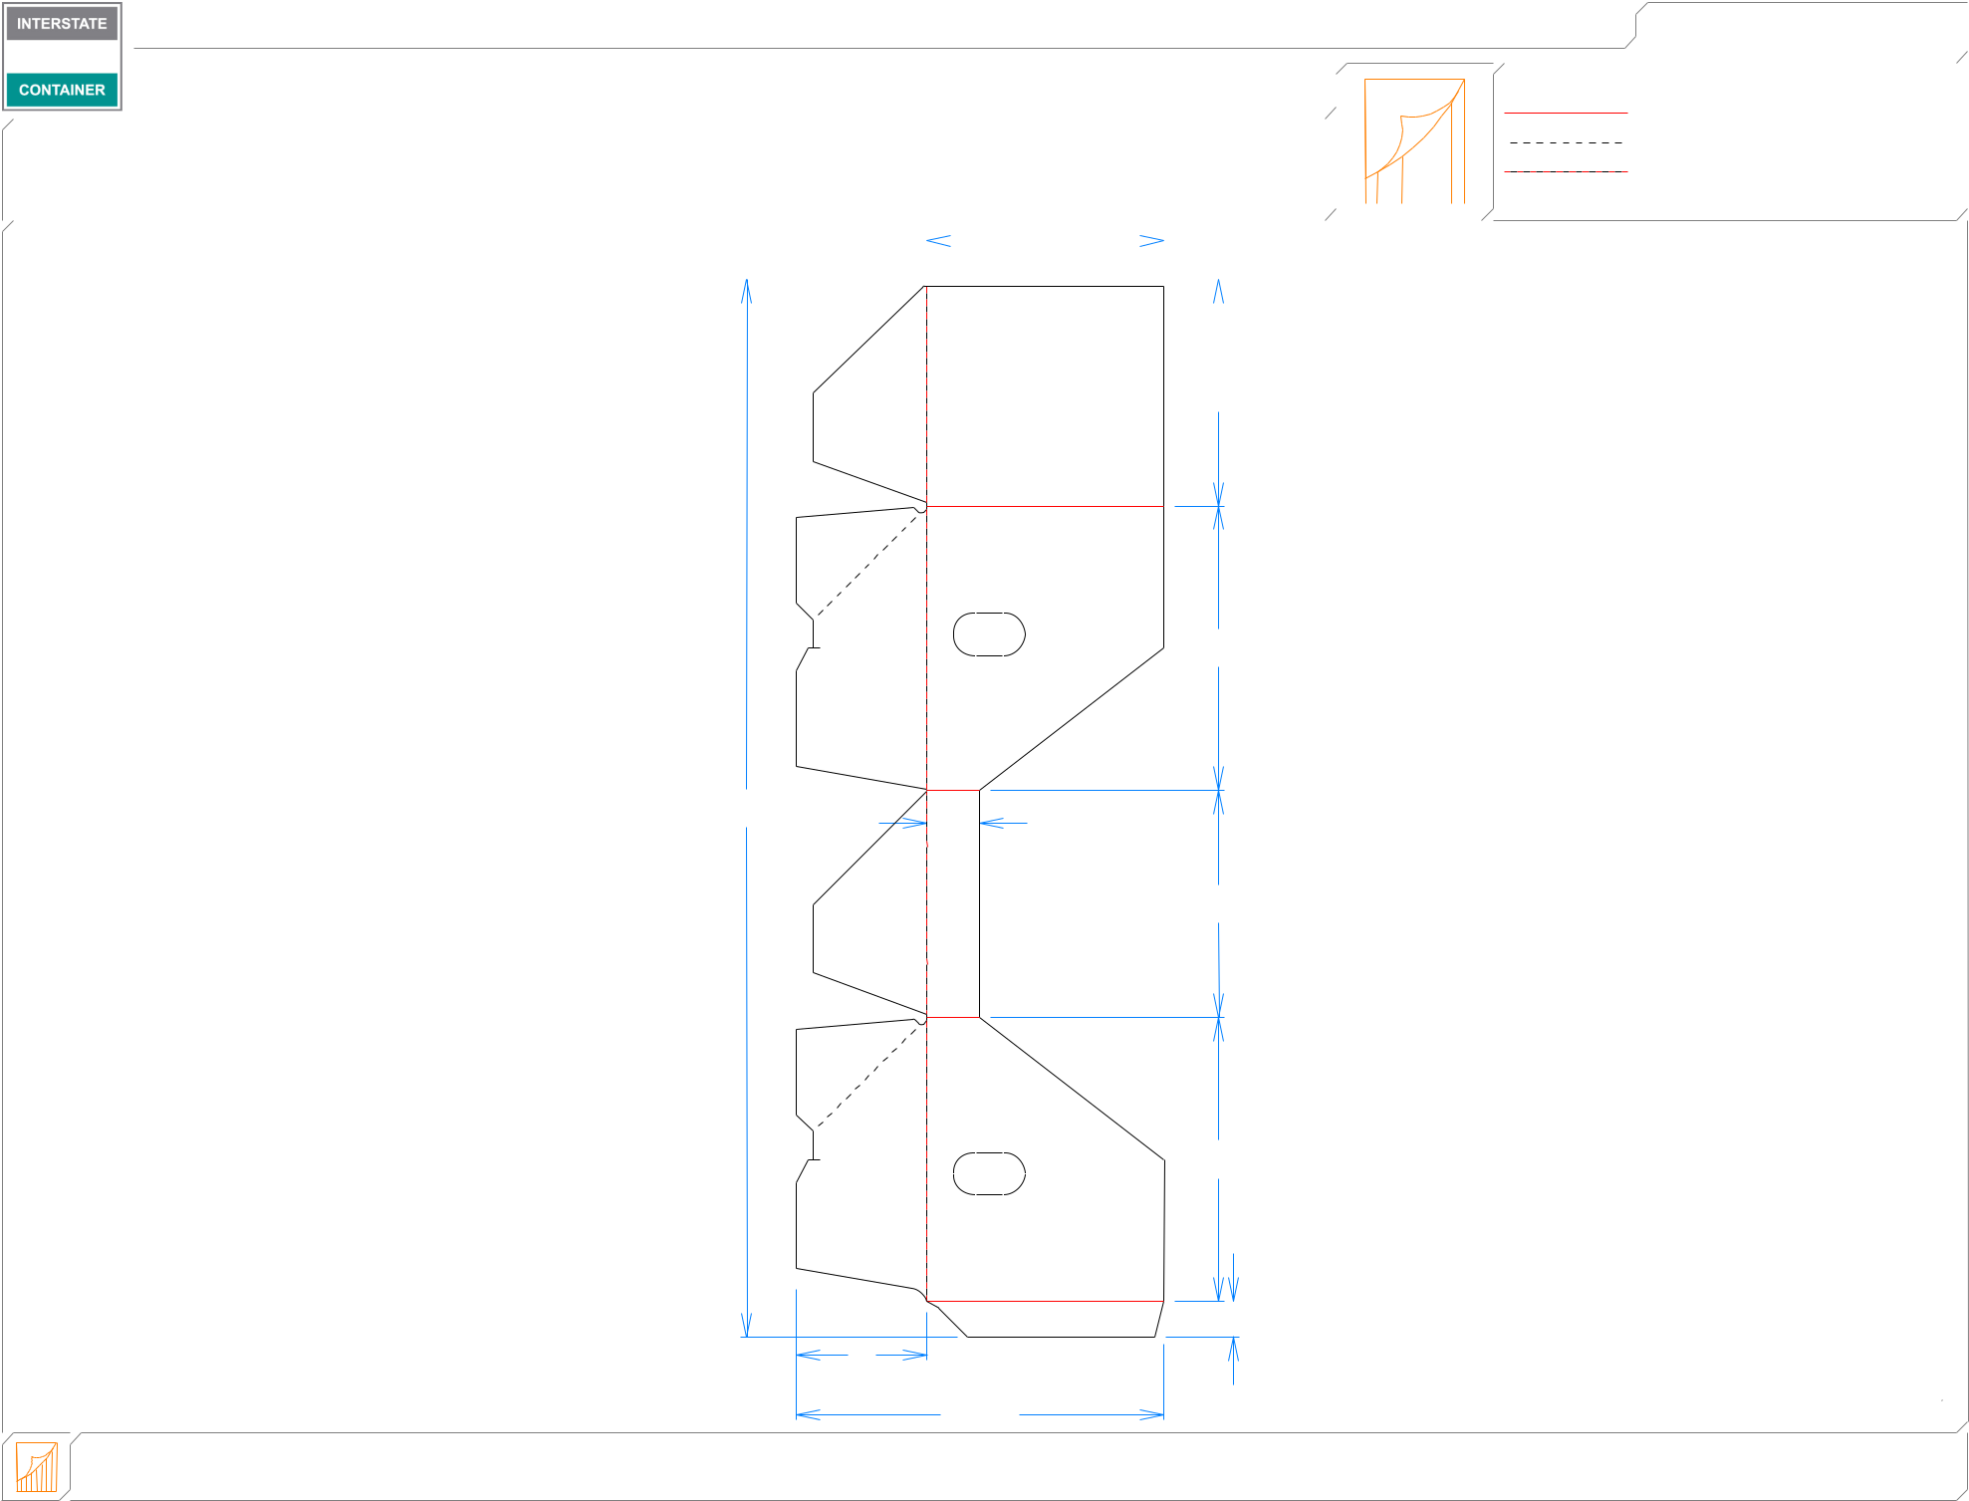

821*/*32

107*/*8

|  |  |  |
| --- | --- | --- |
| 407*/*16 | 2 |  |
|  |  |

811*/*16

1027*/*32

|  |  |  |  |  |  |  |
| --- | --- | --- | --- | --- | --- | --- |
|  |  | 5 |  | 13*/*8 |  |  |
|  |  |  |  |  |  |
| **inside view** | ***notes:* Poly Joined Item** |  | 141*/*16 |  |  |  |
|  |  |  | ***B-13286*** |  |
| **Vertical Corrugation** | ***Qty/unit:*** | ***Area - waste:* 8.51 sq. ft** | ***Waste on blank:* 13.0%** | ***Piece weight - waste:* 1.06 lbs./480.9 g** |  |